1. Design DFA using simulator to accept the string the end with abc over set {a,b,c)

W= abbaababc

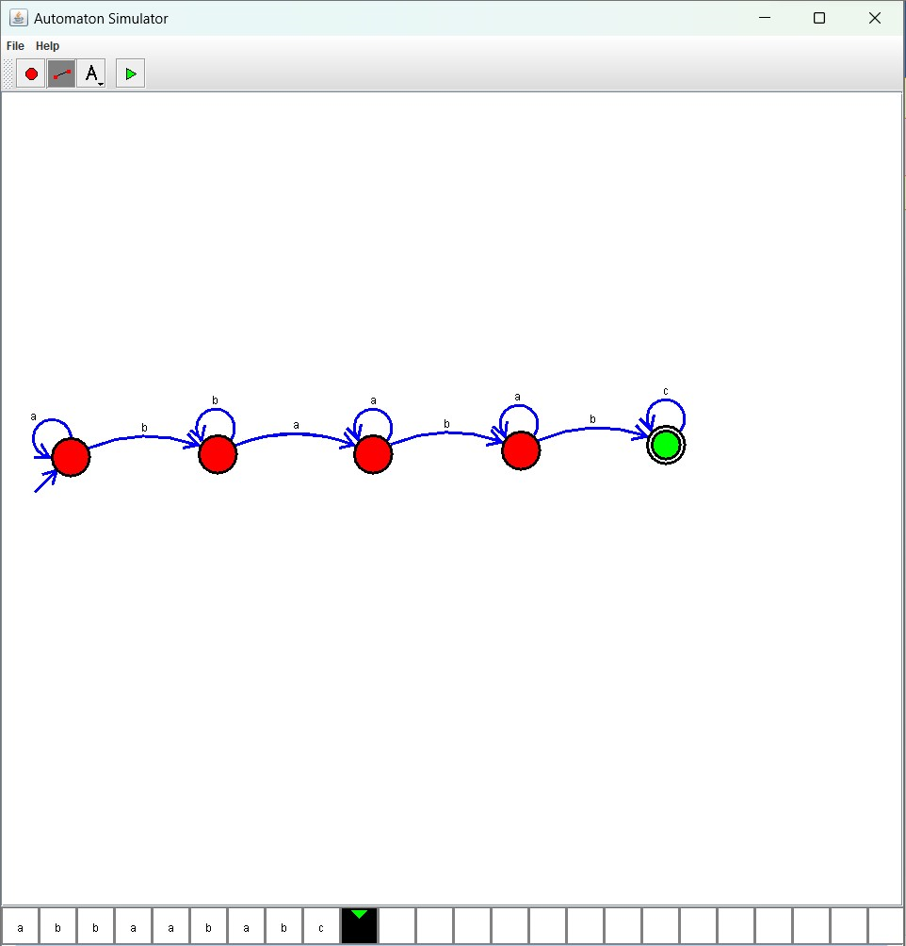

Result :

The simulator is accepted the string the end with abc over set {a,b,c) W=abbaababc by using the above DFA diagram